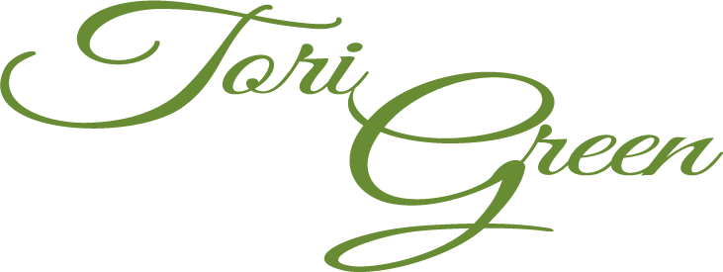

(303) 594 - 4767

tagreen22@gmail.com

<agreentportfolio.com>

**EDUCATION:**

Colorado State University - Fort Collins, CO Aug. 2012 - Dec. 2015

Bachelor of the Arts in Journalism & Media Communication

Minor in Arts Leadership & Administration, *Summa Cum Laude*

**EXPERIENCE:**

**Development Event Intern** - The Catholic Foundation Alliance June 2015 - Aug. 2015

Input constituent contact information and donation items, drafted email reminders, assisted with logistics and day of set-up/tear-down for two golf tournaments and a donor reception

**Program Marketing Intern** - Silver Kite Community Arts, LLC April 2014 - Oct. 2015

Wrote and distributed monthly press releases, created synergetic publication design materials, unified branding across communication channels, contributed to monthly newsletters, compiled marketing lists, managed event promotion on Facebook and Twitter

**Seamstress** - University for the Arts Costume Shop Aug. 2014 - Dec. 2015

Created costume mockups and finished garments, completed alterations, restocked inventory

**Day of Coordinator** Ryan/White Wedding July 2015

Attended final vendor meetings, set-up event space, acted as event staff liaison and manager

**Server** - Cheddars Casual Café June 2013 - Jan. 2015

Greeted guests, took and delivered orders, handled payments and restocked back of house

**Event Assistant** - CSU Orientation Programs Aug. 2013, Aug. 2014

Set-up/tear-down of 10+ events during freshman orientation weekend “RamWelcome

**LEADERSHIP: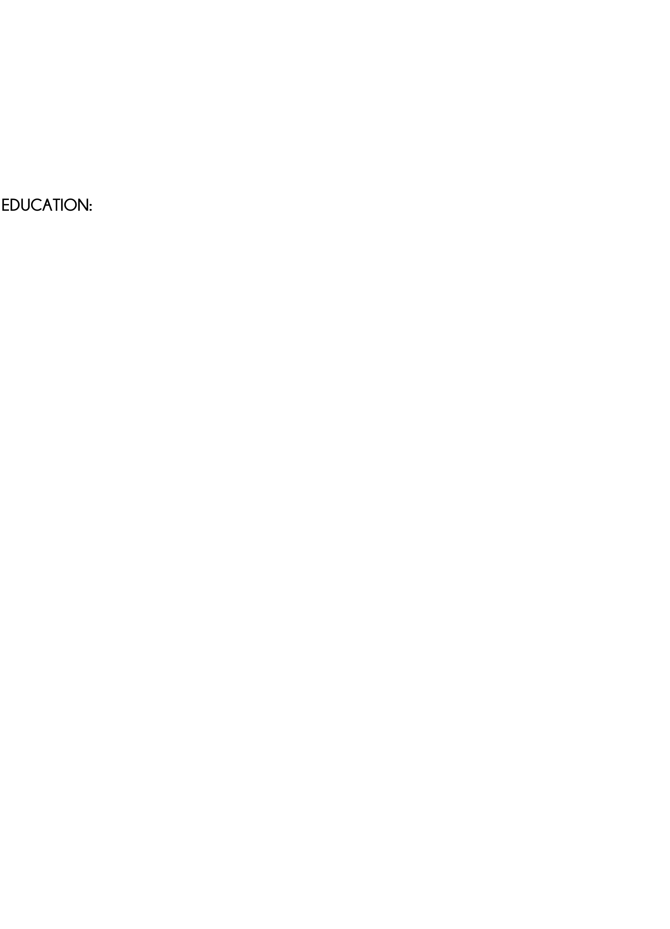ATION:**

**Student Missionary** - Fellowship of Catholic University Students Jan. 2013 - Dec. 2015

Led a weekly Bible study and weekly one-on-one mentoring for 4 student

Summer mission work in Peru, attended 2014 Student Leadership Conference

**Writer** - Ram Catholic Newsletter Sept. 2014 - Dec. 2015

Contributed 2-3 feature articles in bi-annual donor news magazine

**Logistics Coordinator** - TEDxCSU Oct. 2013 - March 2015

Coordinated the innovation expo at a 500 attendee 2014 annual conference

Emcee and venue coordinator for a 100 attendee community 2014 salon

**Development Chair** - Nerdy Derby at NoCo Mini Maker Faire Aug. - Oct. 2014

Organized the procurement of in-kind and monetary donations from 20 local businesses

**Communication**:

Forming creative concepts and branding, Working in collaboration to develop 4-phase campaigns, Using analytics for evaluation

**Software:**

Adobe Photoshop, Illustrator, Premiere, WordPress, Wix, MailChimp, Hootsuite, *GreaterGiving* Project Management

**STRENGTHS & SKILLS:**

**Arts:**

Experience with arts production process including devising works, Planning arts outreach and engagement programming, Online arts promotion

**Events:**

Coordinating 3+ events at once, Building community partnerships, Creating promotional social media/email campaigns, Décor design